DAY BEFORE DELTA
The foamy Delta has been made countless times so it is difficult to devise anything really original, but here are some notes on my version . The “Day Before Delta”, so-called because of its rushed development and production, derives from a simple delta glider I have made many times for my grandchildren and other kids.

The glider is made from half of an A4 sheet of 2mm Depron (from ZART’s in Box Hill: http://www.zartart.com.au/) with the twin fins (and a small throwing fin underneath) hot-glued to the wing. A 15mm section right across the rear is bent up about 3mm at the trailing edge to provide a reflex angle and a suitable blob of Blutak added to the nose so that you obtain a nice flat glide. The model is not a wonderful duration performer (all that wetted area?) but it suits the kids because it is very easy to fly and suits Pop because it is so easy to knock out in a jiffy.
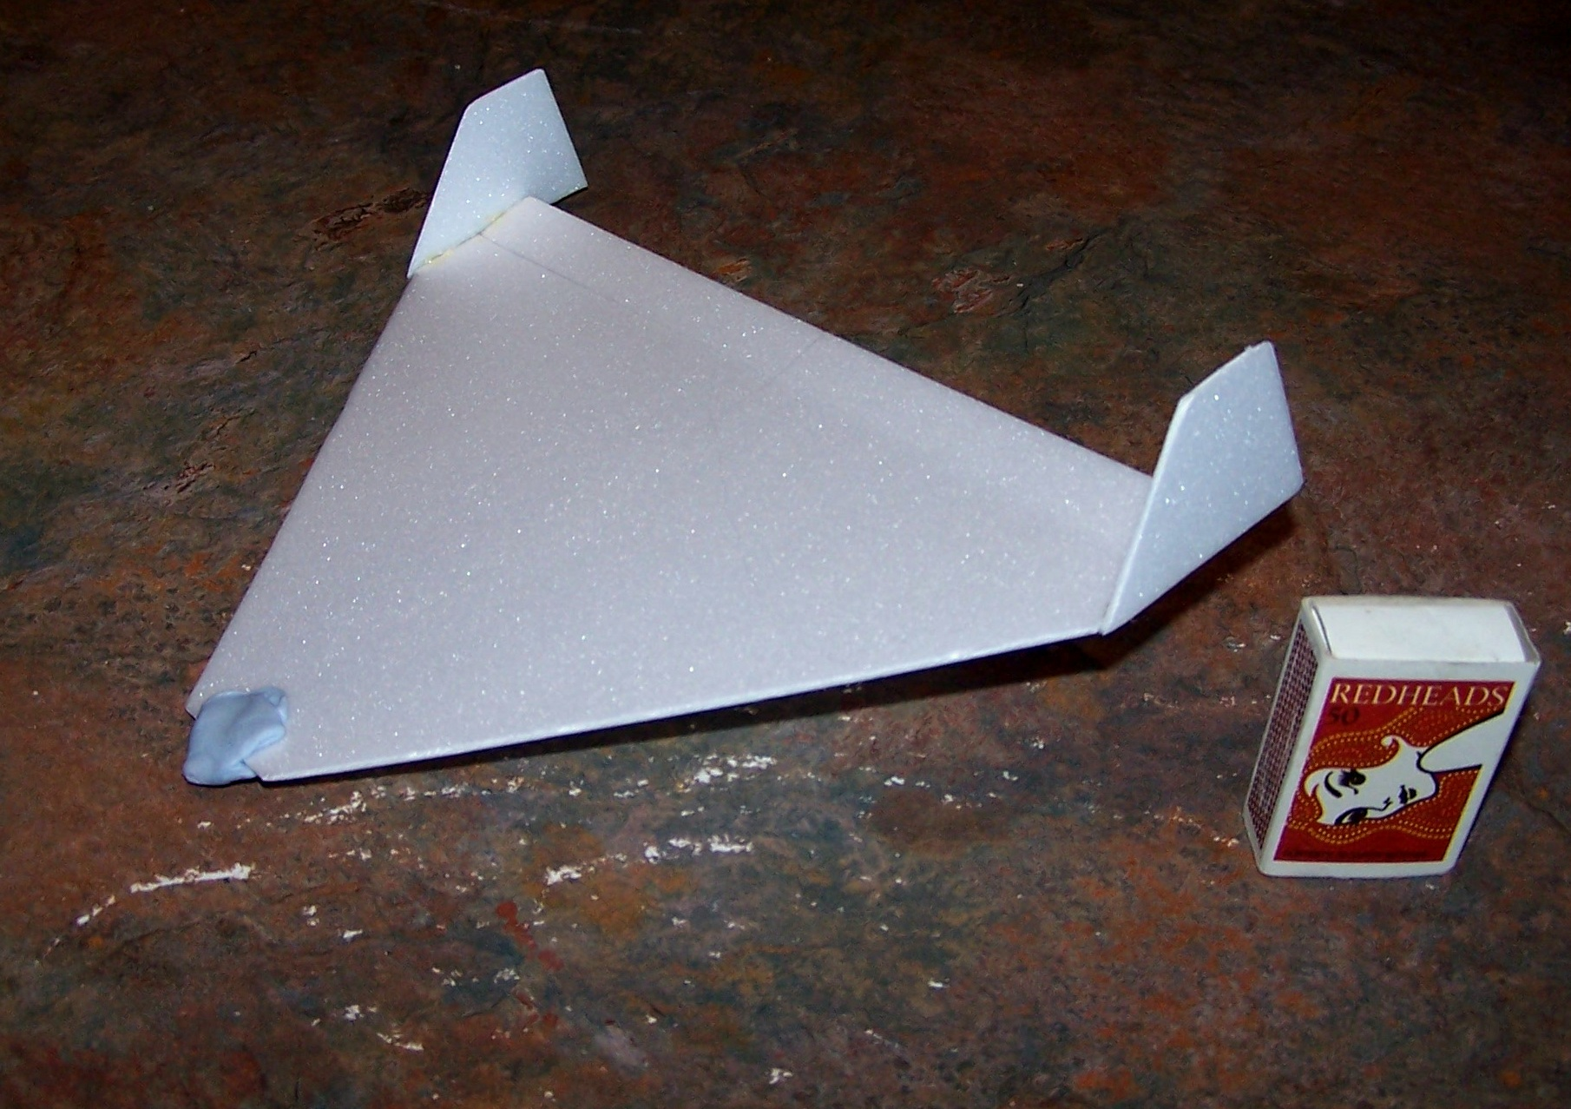

The Day Before Delta is just an enlarged version of the small glider with all the necessary RC bits added. These have become my preferred set of micro gear because of their reliability and are all from Hobby King:
Motor: http://www.hobbyking.com/hobbyking/store/uh_viewItem.asp?idProduct=17155 or
http://www.hobbyking.com/hobbyking/store/uh_viewItem.asp?idProduct=19278
(Have not tried the latter yet, but it could be better)
ESC: http://www.hobbyking.com/hobbyking/store/uh_viewItem.asp?idProduct=11885
Receiver: http://www.hobbyking.com/hobbyking/store/uh_viewItem.asp?idProduct=18827
Servos: http://www.hobbyking.com/hobbyking/store/uh_viewItem.asp?idProduct=17540
Battery: The system takes a single cell. Currently the Parkzone variety 160 mah is used.

I do not believe that the exact dimensions of the model are super-critical but they are outlined on the sketch below. I obtained my 3mm Depron from ZAAT’s but supplies in larger sheets are also available from RAB Hobbies in Parkdale. Perhaps the least attractive (ok, ugliest!) feature of the model is the motor mounting. This is made from a U shaped piece of bendable iron wire (from Bunnings) that is sewn and glued to a block of ¼ inch balsa. The latter is glued to the nose and the motor is fixed to the wire “U” with a small cable tie. The rationale for this arrangement is that down and side thrust are easily incorporated by bending the wire., but the particular motor is awkward to attach anyway. The approach works well in practice, but if you devise a better way, please let me know.
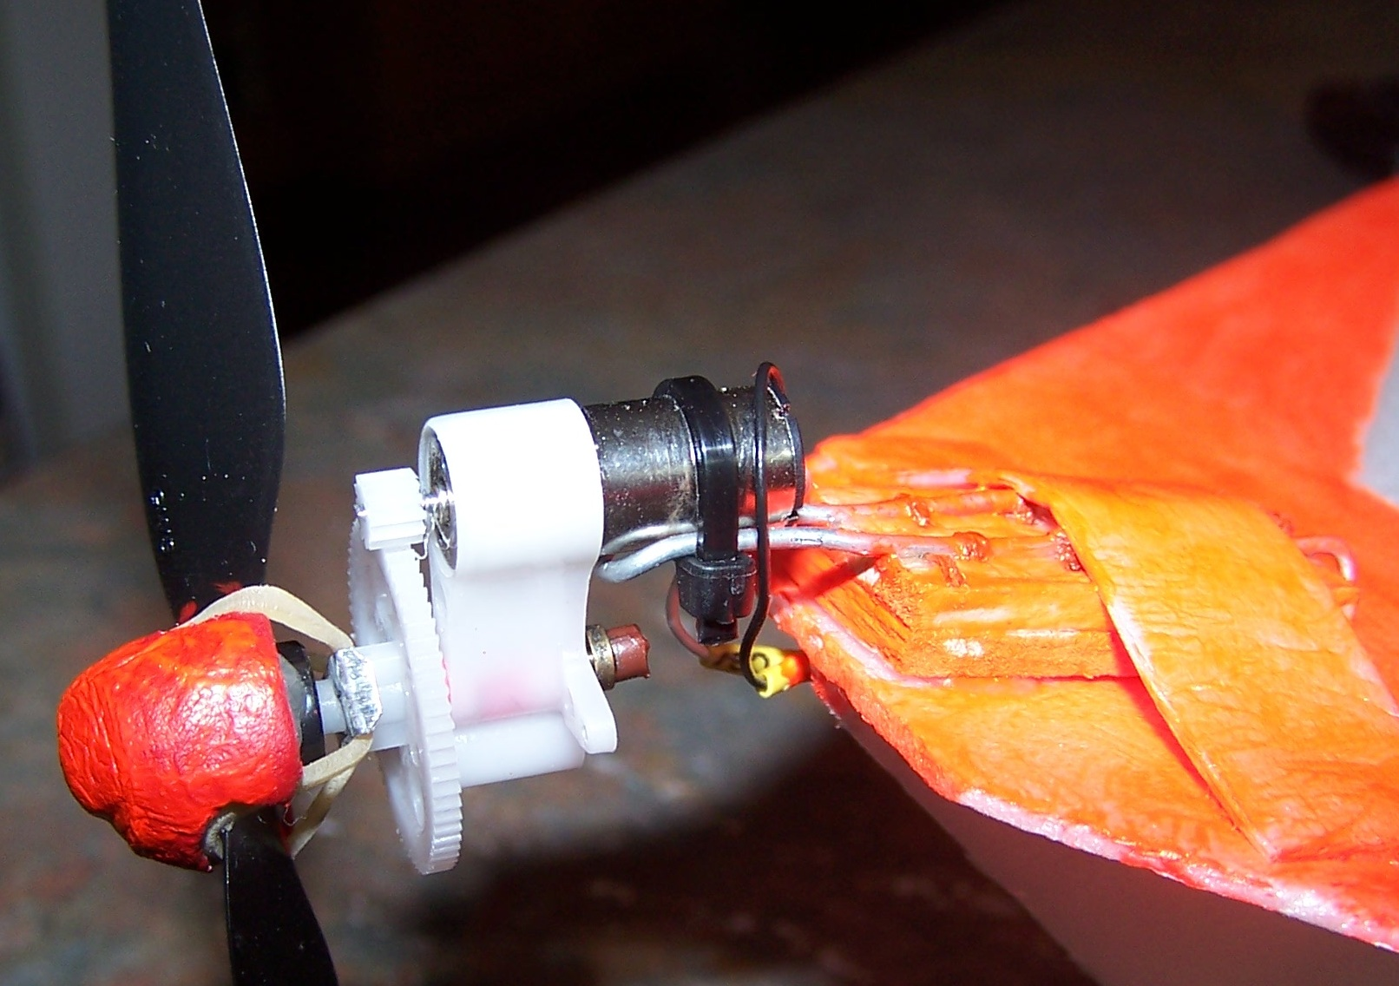
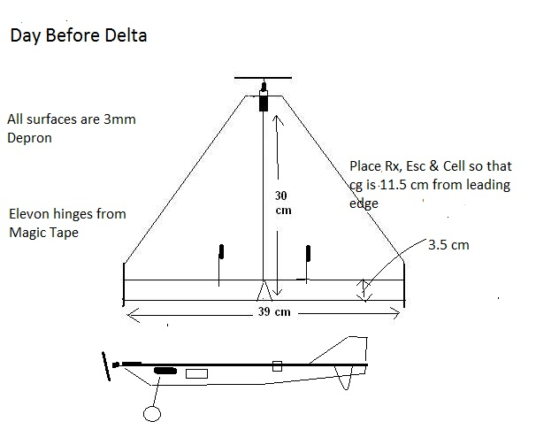
First flights were alarming because my ancient Mode 1 Spektrum DX5e would not cope with the required mixing unless I held the Tx on its side with the sticks reversed! It was time to upgrade. Resisting the temptation to buy the cheap Hobby King Orange DX6i clone, I purchased the real thing from Modelflight and after several hours of frustration finally got everything to work. With proper elevon mixing on the DX6i the model is now flying very well, at least by my standards. Everyone should have a Delta, so If you have a few hours to spare try one like this, or something similar.

